

ASSIGNMENT: MODULE 1.3 JAVA AND JAVAFX SETUP

ELVIA GISELLA ADAIR
STUDENT

LEWIS LATONYA
PROFESSOR

JANUARY 18, 2026
ASSIGNMENT: MODULE 1.3 JAVA AND JAVAFX SETUP

Link Repository: https://github.com/gisellaadair/csd-402

- Capture screenshots, combined in a single Word document, demonstrating you have correctly installed and configured Java and JavaFX. Include your name, date, and assignment number.

JAVA
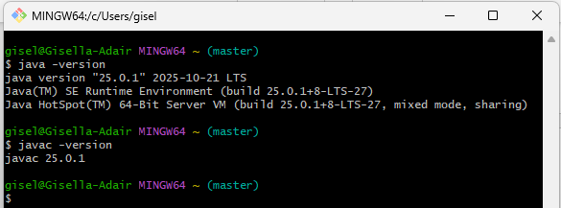
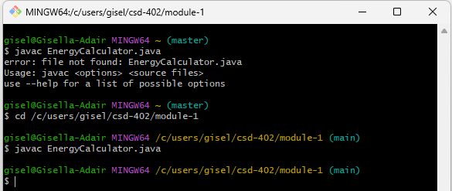
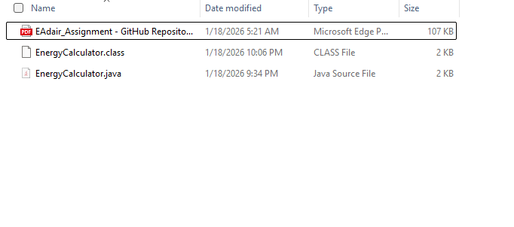
JAVAFX

